**PRACTICAL 07**

**PRACTICAL 07**

**AIM: -** Designing Tableau Dashboards for different displays and devices.

**THEORY**

A dashboard is a collection of several views, letting you compare a variety of data simultaneously. For example, if you have a set of views that you review every day, you can create a dashboard that displays all the views at once, rather than navigate to separate worksheets. Device layouts appear on the Dashboard tab, under Default. Initially, each device layout contains every item in the Default dashboard and derives its size and layout from Default as well. Think of the Default dashboard as the parent, and the device layouts (desktop, tablet, and phone) as its children. Any view, filter, action, legend or parameter that you want to add to a device layout must first exist in the Default dashboard.

**STEPS**

1. Open a dashboard.
2. On the dashboard tab on the left, click Device Preview.
3. Take a moment to click through the device types and models and explore the different screen sizes. Then set these options:
4. To see how the dashboard will look in landscape vs. portrait mode, click on the option available. Usually, landscape is optimal for tablets and portrait is the best for phones.
5. Select tableau mobile app to see how the dashboard will look with the app instead of the browser. The option is available for IOS or Android devices and shrinks the dashboard slightly, leaving space for the app controls.
6. Choose a device type, such as tablet.
7. Click through the device model options to see how the layout will appear on different models.
8. At left, explore the options under size.
9. Default.
10. Fit all
11. Fit width

**RESULTS**

1. **Desktop preview**

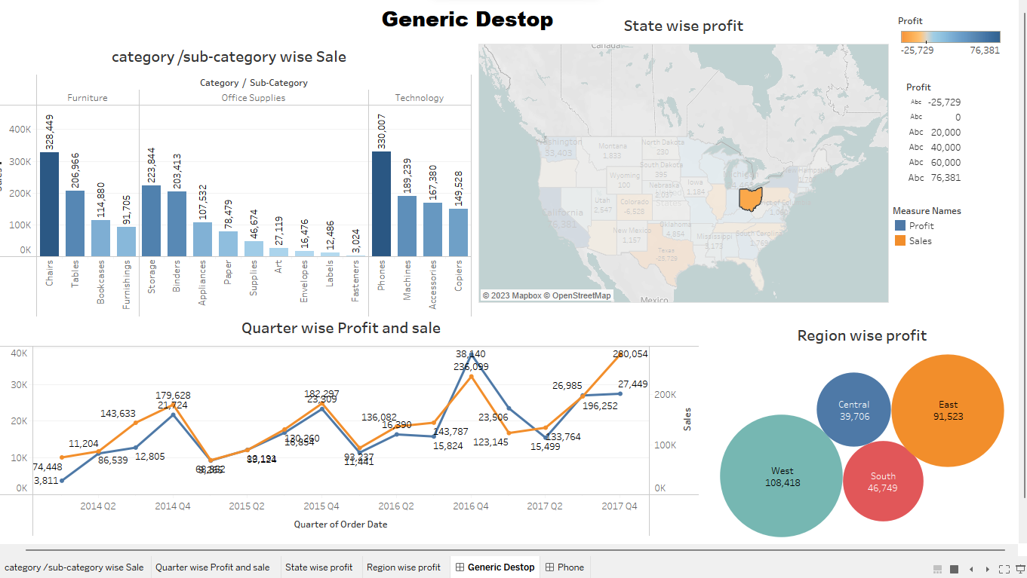

1. **Phone preview**

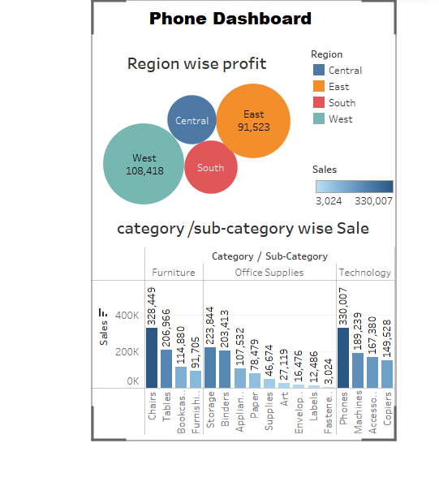

1. **Tablet preview**

